**Assignment**

**허재호**

**데이터 전처리 코드**

import json

import os

import cv2

from PIL import Image

import glob

from tqdm import tqdm

import shutil

from sklearn.model_selection import train_test_split

def bbox_crop_images(json_data_path, images_path) :

    with open(json_data_path, 'r', encoding='utf-8') as j :

        json_data = json.load(j)

    files = os.listdir(images_path)

    for file in tqdm(files) :

        json_infos = json_data[file]

        annotations = json_infos['anno']

        for i, annots in enumerate(annotations) :

            label = annots['label']

            bbox = annots['bbox']

            os.makedirs(os.path.join("./data/metal_damged", 'data', label), exist_ok=True)

            os.makedirs(os.path.join("./data/metal_damged", 'train', label), exist_ok=True)

            os.makedirs(os.path.join("./data/metal_damged", 'val', label), exist_ok=True)

            x, y, w, h = bbox

            img = cv2.imread(os.path.join(images_path, file))

            cropped_img = img[y:y+h, x:x+w]

            file_name = file.split(".")[0]

            new_file_path = os.path.join("./data/metal_damaged", "data", label, f"{file_name}_cropped_{str(i).zfill(1)}.png")

            print(new_file_path)

            cv2.imwrite(new_file_path, cropped_img)

def expend2square(pil_image, background_color):

    width, height = pil_image.size

    if width == height:

        return pil_image

    elif width > height :

        result = Image.new(pil_image.mode, (width, width), background_color)

        result.paste(pil_image, (0, (width-height) // 2))

        return result

    else:

        result = Image.new(pil_image.mode, (height, height), background_color)

        result.paste(pil_image, ((height-width) // 2, 0))

        return result

def resize_with_padding(pil_image, new_size, background_color):

    img = expend2square(pil_image, background_color)

    img = img.resize((new_size[0], new_size[1]), Image.ANTIALIAS)

    return img

def resize_images(data_path) :

    img_path_list = glob.glob(os.path.join(data_path, "*","*.png"))

    for img_path in tqdm(img_path_list):

        try:

            dir, file = os.path.split(img_path)

            folder_name = dir.rsplit('\\')[1]

            os.makedirs(os.path.join("./data/metal_damaged/resized", folder_name), exist_ok=True)

            name = os.path.basename(img_path).rsplit('.png')[0]

            img = Image.open(img_path).convert('RGB')

            img_new = resize_with_padding(img, (256,256), (0,0,0))

            save_file_name = f"./data/metal_damaged/resized/{folder_name}/{name}.png"

            img_new.save(save_file_name, "png")

        except Exception as ex:

            print(f"Error occurs on : {file} with the reason of {ex}")

def file_split(src, dst) :

    files = glob.glob(os.path.join(src, "*", "*"))

    train_list, val_list = train_test_split(files, test_size=0.1)

    for file in train_list :

        folder_path = file.split("\\")[1]

        shutil.copy2(file, os.path.join(dst, "train", folder_path))

    for file in val_list :

        folder_path = file.split("\\")[1]

        shutil.copy2(file, os.path.join(dst, "val", folder_path))

    print("File Split Completed")

json_data_path = "./data/data/anno/annotation.json"

images_path = "./data/data/images"

bbox_crop_images(json_data_path, images_path)

resized_data_path = "./data/metal_damaged/data"

resize_images(resized_data_path)

src = "./data/metal_damaged/resized"

dst = "./data/metal_damaged/"

file_split(src, dst)

**데이터 전처리 결과**

Figure Outputs

Figure Cropped data

Figure Resized with padding data

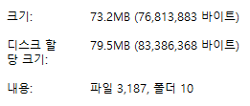

Figure Train data

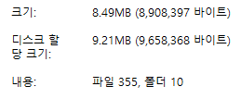

Figure Test data

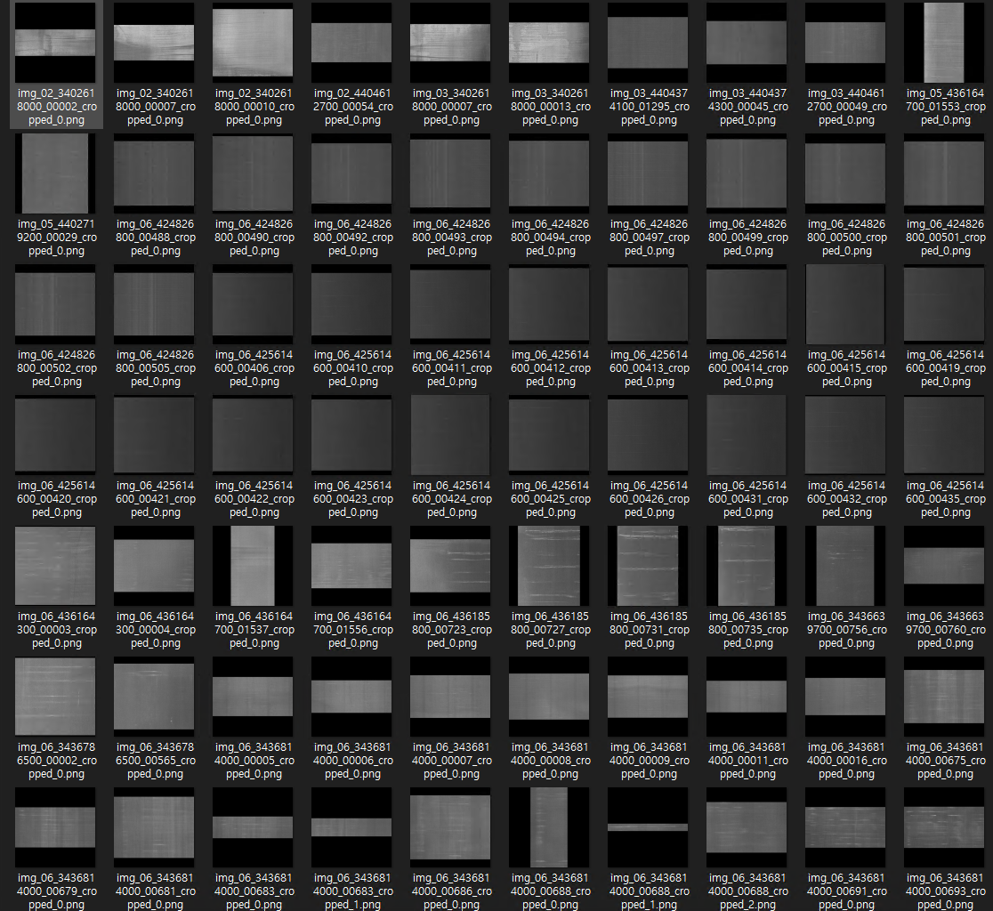

Figure Images

**학습 결과**

Epoch [1/20], Train Loss : 1.4055, Train Acc : 0.5723, Val Loss : 0.4810, Val Acc : 0.8507

Epoch [2/20], Train Loss : 0.5005, Train Acc : 0.8431, Val Loss : 0.4443, Val Acc : 0.8676

Epoch [3/20], Train Loss : 0.3955, Train Acc : 0.8798, Val Loss : 0.3422, Val Acc : 0.8873

Epoch [4/20], Train Loss : 0.3266, Train Acc : 0.8987, Val Loss : 0.2809, Val Acc : 0.9070

Epoch [5/20], Train Loss : 0.3325, Train Acc : 0.8968, Val Loss : 0.3390, Val Acc : 0.8958

Epoch [6/20], Train Loss : 0.2797, Train Acc : 0.9112, Val Loss : 0.3260, Val Acc : 0.9155

Epoch [7/20], Train Loss : 0.2768, Train Acc : 0.9118, Val Loss : 0.2991, Val Acc : 0.9127

Epoch [8/20], Train Loss : 0.2678, Train Acc : 0.9156, Val Loss : 0.2359, Val Acc : 0.9211

Epoch [9/20], Train Loss : 0.2422, Train Acc : 0.9247, Val Loss : 0.2757, Val Acc : 0.9239

Epoch [10/20], Train Loss : 0.2405, Train Acc : 0.9200, Val Loss : 0.3190, Val Acc : 0.9183

Epoch [11/20], Train Loss : 0.2332, Train Acc : 0.9216, Val Loss : 0.2994, Val Acc : 0.9070

Epoch [12/20], Train Loss : 0.2131, Train Acc : 0.9278, Val Loss : 0.4208, Val Acc : 0.9099

Epoch [13/20], Train Loss : 0.2243, Train Acc : 0.9272, Val Loss : 0.3137, Val Acc : 0.9155

Epoch [14/20], Train Loss : 0.1893, Train Acc : 0.9426, Val Loss : 0.3080, Val Acc : 0.9155

Epoch [15/20], Train Loss : 0.1893, Train Acc : 0.9366, Val Loss : 0.2732, Val Acc : 0.9239

Epoch [16/20], Train Loss : 0.1808, Train Acc : 0.9432, Val Loss : 0.3007, Val Acc : 0.9042

Epoch [17/20], Train Loss : 0.1699, Train Acc : 0.9435, Val Loss : 0.3201, Val Acc : 0.8986

Epoch [18/20], Train Loss : 0.1726, Train Acc : 0.9426, Val Loss : 0.2417, Val Acc : 0.9268

Epoch [19/20], Train Loss : 0.1743, Train Acc : 0.9404, Val Loss : 0.2570, Val Acc : 0.9155

Epoch [20/20], Train Loss : 0.1649, Train Acc : 0.9463, Val Loss : 0.2431, Val Acc : 0.9380

**테스트 결과**

Test Set : Acc [333/355] 94%

**힉습에 사용한 하이퍼 파라미터**

epochs = 20

criterion = CrossEntropyLoss().to(device)

optimizer = Lion(model.parameters(), lr=1e-4, weight_decay=1e-2)